Installing Citrix Receiver on Windows 7/10 (External PCs)
- Download the “Citrix Client for Windows” client at: http://atnyulmc.org/sites/default/files/CitrixReceiver49.exe
Right click CitrixReceiver.exe and then from the Downloads folder, right-click and select “Run as administrator” (if you don’t see this option, just select “open”)
Note: Needs Administrator privileges to install
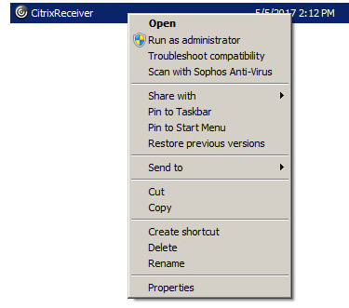
Click “Start” button
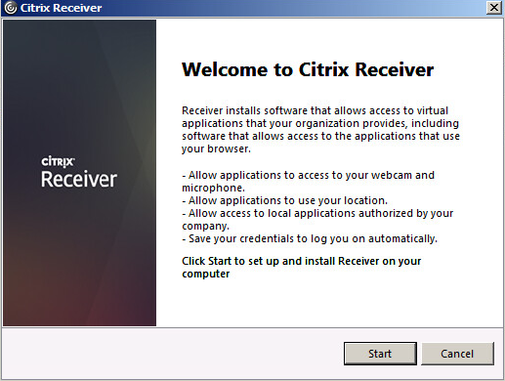

Click Accept and Next
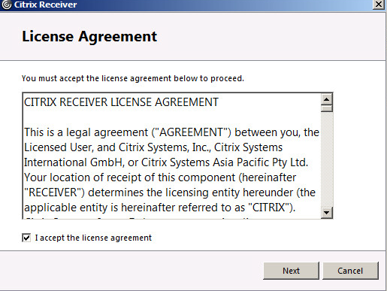
IMPORTANT: Since this is for External/Home computer, Please Uncheck the “enable single sign-on” (if you see this screen).
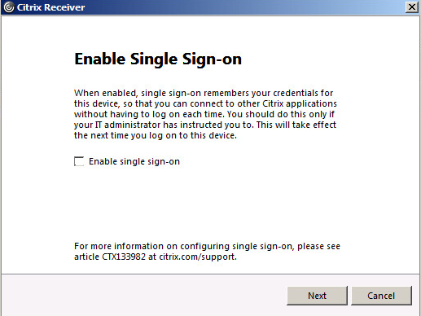
Select “No” below and click Install
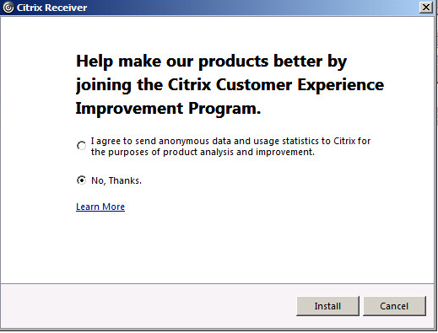
After Install is completed, click Finish
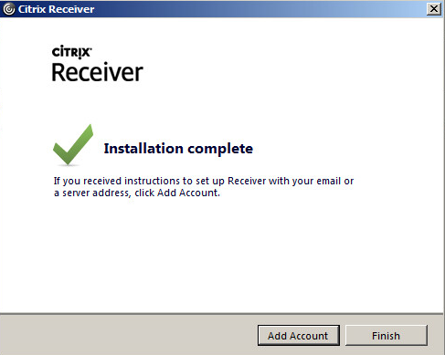
Note: You do NOT need to configure Account or anything additional as you will be utilizing Portal links to access your Citrix applications.

